**Family Relationship Knowledge Base – Documentation**

**Introduction**

This project implements a simple family tree program in Prolog to represent and query relationships among family members. The objective is to define basic relationships using Prolog facts (e.g., parent/2, male/1, female/1) and to create rules for derived relationships such as father/2, mother/2, siblings/2, and children_of/2. This work explores logical inference and pattern matching in Prolog.

Implementation

The implementation begins with facts that specify parent–child relationships and gender. For example, parent(john, mary). states that John is a parent of Mary. Gender is defined using male/1 and female/1.

Rules are then defined to infer relationships:

* father(F, C) is true if F is male and a parent of C.
* mother(M, C) is true if M is female and a parent of C.
* siblings(X, Y) is true if X and Y share a parent and are different individuals.
* children_of(Parent, Children) uses findall/3 to return a list of all children of a given parent.

A separate sample_queries.pl file contains example queries to demonstrate the program's use.

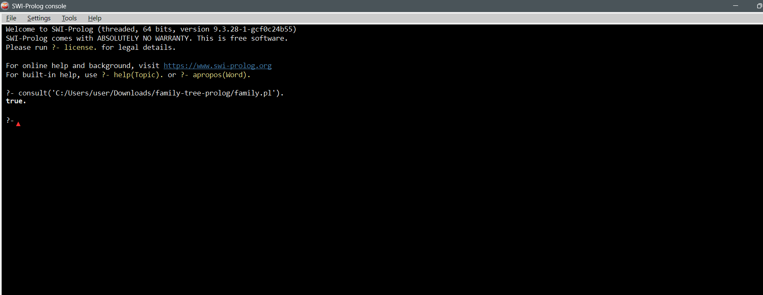

**Sample Queries and Expected Output**

1. **Find John’s children**

?- children_of(john, Children).

Children = [mary, tom].

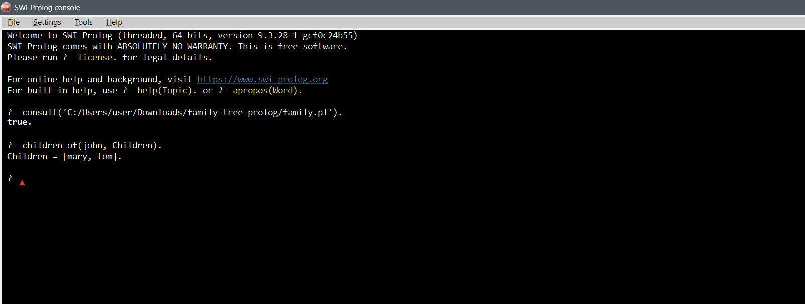

Who is Mary’s mother?

?- mother(M, mary).

M = susan.

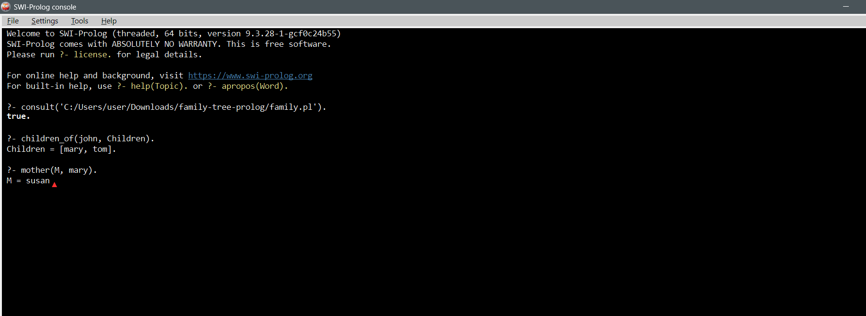

Who are Alice’s siblings?

?- siblings(alice, Sibling).

Sibling = bob.

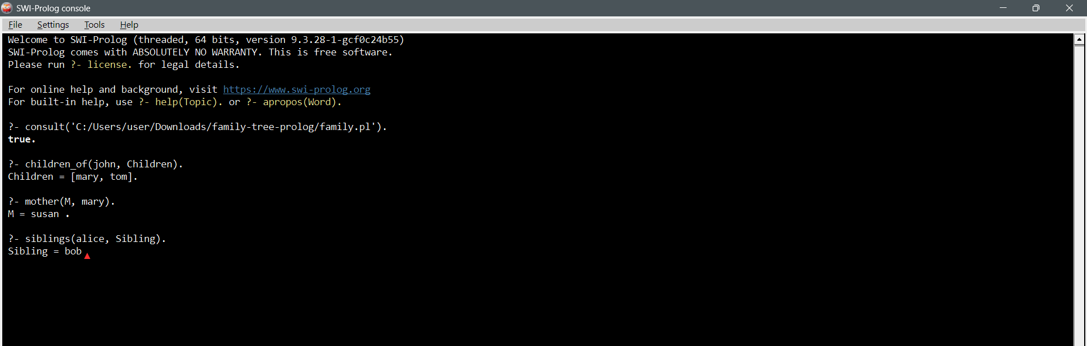

List all fathers

?- father(F, _).

F = john ;

F = paul.

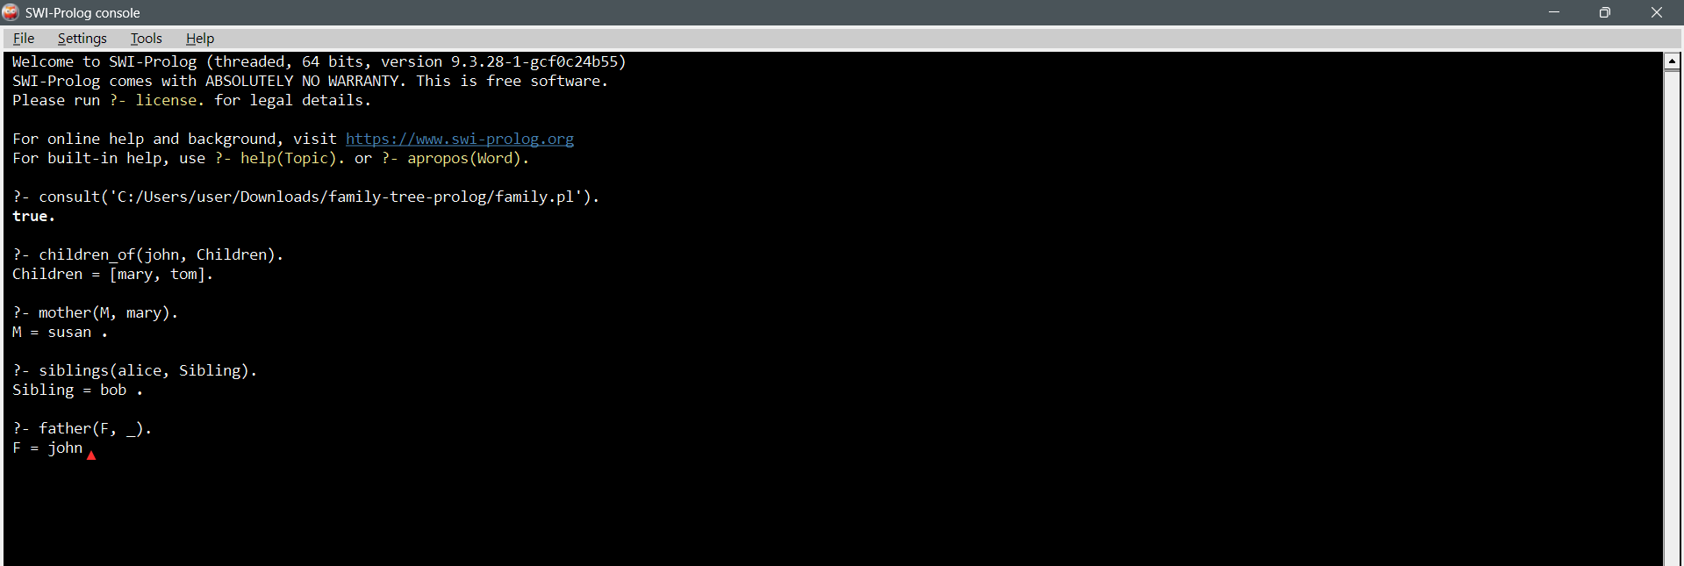

**Challenges and Lessons Learned**

One minor challenge was ensuring that predicates were correctly defined and that facts for male/1 and female/1 were grouped together to avoid discontiguous predicate warnings in SWI-Prolog. Another important aspect was using findall/3 to retrieve lists of related individuals, which required understanding Prolog’s list construction and backtracking behavior. Through this project, the importance of clear fact structuring and the expressive power of logic programming became evident.

**Conclusion**

The Prolog family tree program successfully models family relationships and demonstrates logical inference through simple facts and rules. The program can be extended with additional relationships, such as grandparents or cousins, by introducing recursive rules. This exercise highlights Prolog’s suitability for knowledge representation and reasoning tasks.